Government of Khyber Pakhtunkhwa
Health Department

PC-I
0
2025-2028

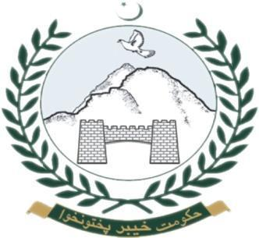

ADP No. 446, CODE No. 240232

Total Cost: PKR 898.26 million (Revenue)

